VACANCY
Employment Type: Full Time  Salary L13 – L19  Closing Date: 24 March 2025  Date of interviews: 24 & 25 April 2025  Position start date: September 2025 | 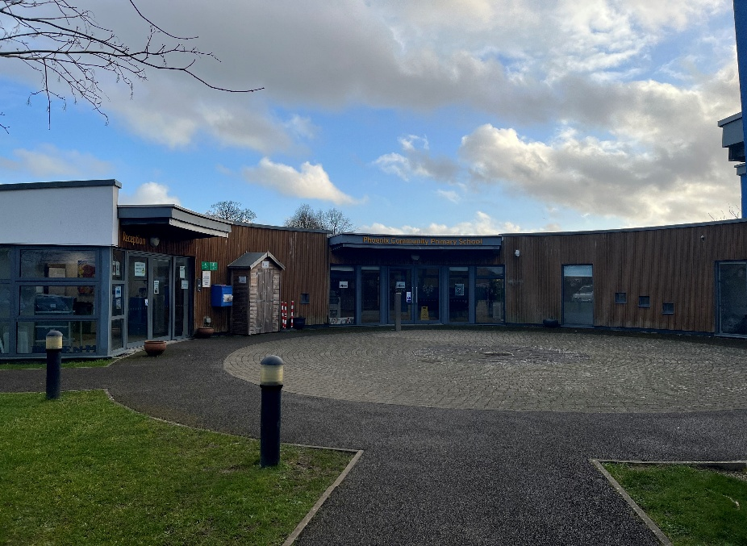

Are you a leader who builds strong relationships with children and adults alike, and who fosters a love for lifelong learning and education?
We are seeking to appoint a Headteacher who can bring a range of experience and opportunities to our school and the wider CARE Foundation Trust of which Phoenix is a member.
We are looking for:
- A qualified teacher with leadership experience at a senior level, with experience in school improvement
- A proven track record of raising standards and achieving excellent academic outcomes, even in challenging circumstances
- Strong strategic vision and the ability to translate this into an impactful and clear school improvement plan, focused on addressing identified areas
- Track record of communicating and working effectively in partnership with parents, carers, governors and the wider community
- The ability to build strong relationships, foster collaboration, and promote a culture of openness and trust
- A commitment to safeguarding and promoting the well-being of all staff & children
- It is desirable for the successful applicant to have a good working knowledge and experience of working with children with SEND.
What the school offers its staff
Phoenix Community Primary School is a fantastic one form entry primary school that sits within an established group of 9 other supportive schools that form the CARE Foundation Trust. This is an excellent opportunity to work collaboratively with colleagues across the Trust, to share expertise and experience, ensuring all children in our schools receive an excellent education and reach their potential. Headteachers and staff meet regularly through the Trust to share experience and knowledge and to establish best practice, you would be an active participant providing contributions and receiving the benefits of the work of the Trust.
We want a headteacher who is going to give our children the very best start in their life and who will be their champion through early years and key stages 1 and 2.
We are passionate about building a strong moral compass in every child. We believe that effective relationships at all levels are vital to provide every child with the foundations upon which learning can take place.
Our school benefits from extensive grounds which is well resourced with activities for our children and, an award winning modern building. We share part of our building with Sure Steps and the local Library but of course we have within the school a library which is enjoyed by all the children. We also have a private nursery within our grounds.
We Offer
- A welcoming environment full of warmth and kindness
- The opportunity to lead a dedicated and committed staff team who all put the children at the heart of their work and decision making
- The chance to enrich the education of the children and make a significant impact
- Wonderful children who are happy and keen to learn
- The chance to make a significant and lasting impact on a school community some of whom face significant challenges and disadvantage
- A role that will stretch and challenge you, offering a high level of professional satisfaction
- A supportive governing board, who will work positively with you
Do come and speak to our children who are the best ambassadors of the school and will tell you all about their experiences at Phoenix.

